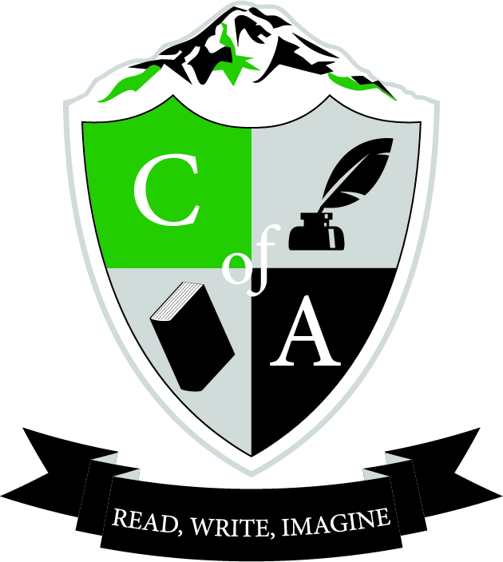
Cavalcade of Authors West

Event Date: Saturday, April 30th, 2016
Event Location: Anderson University Center, Pacific Lutheran University
12598 Park Ave S
Tacoma, WA 98447
Event Times:
Doors open: 8:30 AM
Conference begins/doors close: 9:15 AM
Conference ends: 3:00 PM

www.cavalcadeofauthorswest.com
Twitter | Instagram: @CavalcadeWest #coawest16

Arrival, Parking, and Check-in
Doors open at 8:30 AM in the Anderson University Center. While we do our best to provide a swift check-in process, lines will inevitably develop. It is best if the chaperone(s) greet and collect students in front of the Anderson University Center before getting in line. Last year, schools with two chaperones had one chaperone outdoors greeting students and one in registration for issuing registration packets as students were sent indoors. Check-in will be organized alphabetically by school. T-shirts will be picked up during check-in. The first session begins at 9:15 AM and students should be ready before that.

Student drop-off: Park Avenue and 122nd, right in front of the Anderson University Center which is easily identifiable by the viking ship in front of it. Students should use the entrance by the clock tower, which looks mostly like a tall sculpture. There will be COA West volunteers to assist in directing you to registration.

Parking: Use designated visitor or street parking. Busses may park in the lot on corner of 124th & 10th AVE, in the Olson Auditorium lot.

As a chaperone, you may choose to participate in sessions. Please stay for an entire session. Chaperones did not need to register or sign-up for sessions.

Lunchtime
Lunch is not included with the registration fee. Students are encouraged to bring a sack lunch. At lunchtime you should find your school! Students may purchase lunch in the cafeteria or in the Old Main Market, both located in the Anderson University Center.

What to Bring
Money: Remember that there will be a signing session, so students are encouraged to purchase books for signing. Their t-shirts or programs will also work. This year, posters will be available for purchase onsite for $5 and may also be a good signing option. There will be a very limited supply of t-shirts available onsite for $10.

Writing materials: Bring a notebook and pen/pencil for your sessions! Also, make sure students are prepared to write, even if they don’t consider themselves a writer.
Questions: Students (and chaperones) will be participating in an author panel, and typically the last 10-15 minutes of a panel includes questions from the audience.

Phones: Talk to students about appropriate phone use. Save phones for signing session or panels. We love promotion on social media, but want to be respectful to our hard working authors!

Photo/Video Release
When a student commits to Cavalcade of Authors West, the family or legal guardian is granting permission for the student’s image to potentially appear in future publications. Cavalcade of Authors West may be attended by media organizations and the students in attendance may be recorded, photographed or have other content taken by media organizations invited by CoA West. Throughout the event, CoA West will be taking photos of students engaged in workshops and Cavalcade activities. We intend to use these photos for our website or future promotional publications and presentations. No names of students will be associated with any of the photographs.

Schedule of Events
8:30 – 9:10 Registration/Check-in
9:15 – 10:00 Session 1
Late arrivals will miss the entire session—be on time!
10:15 – 11:00 Session 2
11:15 – 12:00 Session 3
12:05 – 12:55 Lunch
Meet with your school for lunch
1:00 – 1:45 Session 4
2:05 – 3:00 Signing Session
*One of your sessions will include an Author Panel.

Student Checklist
- Eat breakfast! There will be no time for breakfast or snack purchases in the morning.
- Bring a sack lunch or money to purchase your lunch.
- Bring a reusable water bottle.
- Bring money if you wish to purchase books, a poster, or a t-shirt at the event (cash/credit).
- Bring a notebook and pen/pencil
- Follow on Twitter, Instagram, and/or Facebook, and use the official hashtag #coawest16

