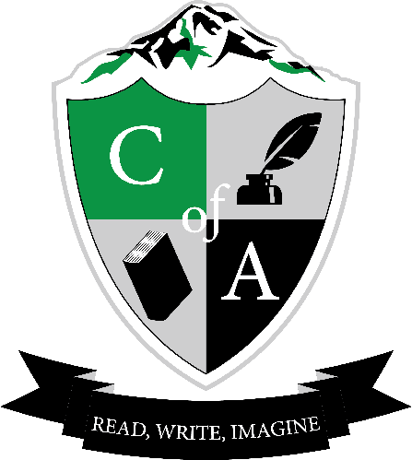 | Cavalcade of Authors West  Reading and writing workshops for secondary students in western Washington.  www.cavalcadeofauthorswest.wordpress.com  Twitter | Instagram: @CavalcadeWest  #coawest15
Hello English Teacher,

Your school librarian has likely heard about the first ever Cavalcade of Authors West, which is going to be held on May 2nd, 2015 at Pacific Lutheran University. We want to let you know that your school is not currently registered, and we think it would be an awesome opportunity for you (and your students)!

Seventeen authors will be coming to PLU on May 2nd to provide writing workshops for secondary school students. We are excited to welcome Royce Buckingham, Kimberly Derting, Peggy Eddleman, Kevin Emerson, Kristin Halbrook, Kazu Kibuishi, Lish McBride, Mindy McGinnis, Richelle Mead, Marissa Meyer, Alyson Noel, Lisa Schroeder, Liesl Shurtliff, Terry Trueman, Leslye Walton, Stasia Ward Kehoe, and Jim Whiting. Please visit our website (www.cavalcadeofauthorswest.com) to see their bios and workshop descriptions for May 2nd.

Qualified students will be attending three 45 minute creative writing sessions each put on by a different author, as well as a panel that features a number of our authors. What makes a qualified student? That’s flexible; at this point, students may not be able to read four books by our authors in time, but if you have a writing club or students who just love books, there’s definitely a place for them at Cavalcade! Please email us for due dates for participation.

We currently have 300 students registered from a number of Pierce County schools, but we’re missing your school. If this sounds like an activity you would be willing to take on, you may want to check-in with your librarian to see if s/he is willing to collaborate, or, you can definitely be the coordinator for your school.

We are excited to bring this opportunity to Western Washington. Please visit our website and follow us on Twitter and Instagram to keep in touch, and, to stay in the loop for next year if this year doesn’t work out.

Sincerely,

Carina Pierce, President, Cougar Mountain Middle School Teacher Librarian
Kari Bradley, Curtis Junior High English Teacher
Virginia Larsen, Ferrucci Junior High English Teacher
Carrie Willenbring, Bethel Middle School Teacher Librarian
Lizz Zitron, PLU Librarian
coawest@gmail.com

