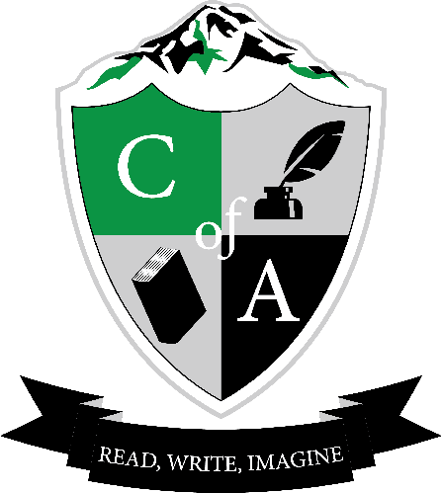 | Cavalcade of Authors West  Workshop Preference Form 2016  www.cavalcadeofauthorswest.com  Twitter | Instagram: @CavalcadeWest #coawest16  Facebook: Cavalcade of Authors West  Name:__________________________________________ Grade:_____  School: __________________________
Please rank your Top 8 authors that you would like to work with at the Cavalcade of Authors conference on Saturday, April 30th. Number 1 would be your first choice, 2 your second choice, and so on. We will try to give you your top choices, but have to consider space and availability.

**The Cavalcade West board will do their best to match you up with your preferred choices, but please understand you may be slated to work with an author whose books you haven’t read. We know it’ll be an awesome day and you’ll enjoy going where ever you’re assigned.
Frank Beddor
S.A Bodeen
Martha Brockenbrough
Royce Buckingham
Justina Chen
Kimberly Derting
Carl Deuker
Kevin Emerson
April Henry
Colleen Houck
Kazu Kibuishi
Lish McBride
William Ritter
Heidi Schulz
Tamara Ireland Stone

