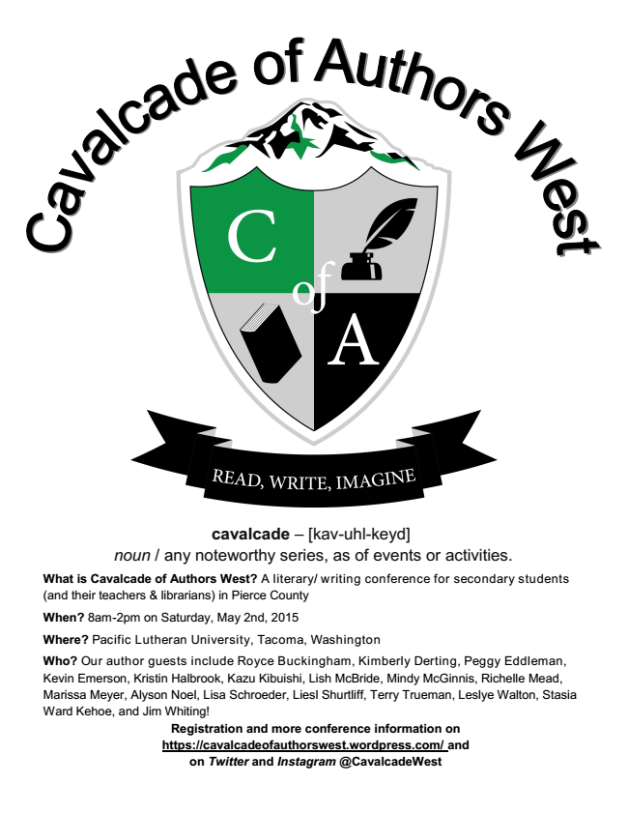
cavalcade – [kav-uhl-keyd] noun / any noteworthy series, as of events or activities.
What is Cavalcade of Authors West? A literary/ writing conference for secondary students (and their teachers & librarians) in Pierce County
When? 8am-2pm on Saturday, May 2nd, 2015
Where? Pacific Lutheran University, Tacoma, Washington
Who? Our author guests include Royce Buckingham, Kimberly Derting, Peggy Eddleman, Kevin Emerson, Kristin Halbrook, Kazu Kibuishi, Lish McBride, Mindy McGinnis, Richelle Mead, Marissa Meyer, Alyson Noel, Lisa Schroeder, Liesl Shurtliff, Terry Trueman, Leslye Walton, Stasia Ward Kehoe, and Jim Whiting!
Registration and more conference information on https://cavalcadeofauthorswest.wordpress.com/ and on Twitter and Instagram @CavalcadeWest

